Appendix 2
Future Growth of Christchurch
The Christchurch urban area has expanded in the past 30 years, increasing in size from approximately 8,800 hectares in 1970 to approximately 11,800 hectares in 2000.

Urban growth has occurred as a result of population growth, changing household structure (including ageing population, family changes, the decline in the household occupancy rate) and lifestyle preferences (for example, inner city apartment versus suburban residential versus rural lifestyle living) which drive housing demand.

1970 1990 2000
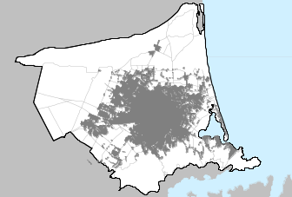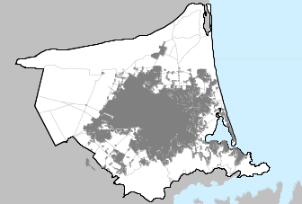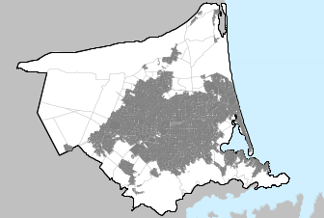
N
Urban growth also results as a consequence of where development is allowed to be undertaken. With a primary emphasis on consolidation, the Council’s objective is to accommodate urban growth within the city boundary, through the gradual infill or redevelopment of existing areas. It is anticipated this will result in an increase in population and housing densities in the inner suburbs around the Central City, and around consolidation focal points, such as the Hornby, New Brighton, Papanui, Woolston and Sumner suburban centres.

The North-east, South-West and Northern areas of the city have significant areas of vacant land with residential capacity. This is as a result of Council rezoning in 1999. The total area of land available on the Port Hills has been slowly increasing over time, and the Port Hills is the area of the city with the greatest quantity of vacant residential land. Vacant land within the Inner City has stayed relatively stable, and at a low level, from 1994 to 2003.
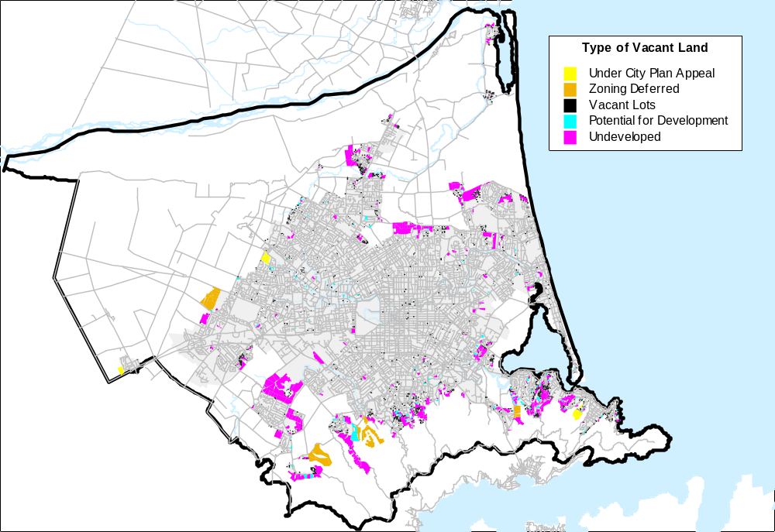

Take up rates of vacant land do not necessarily correspond with land availability. Areas with the highest take-up rates in the period 1994 to 2003, have been the North-east, North-west, and South-west (in decreasing order). The South-east and Port Hills have generally showed decreasing trends in take-up, however all areas increased levels of take-up in the year to June 2003. As at June 2003 there was over 1,300 hectares of available vacant residential land in the city. While the majority of this (937 hectares) was undeveloped, 288 hectares, equating to 3,400 lots, was available to be built on.

Take up of residential vacant land by Port Hills area Unit 1994-2004
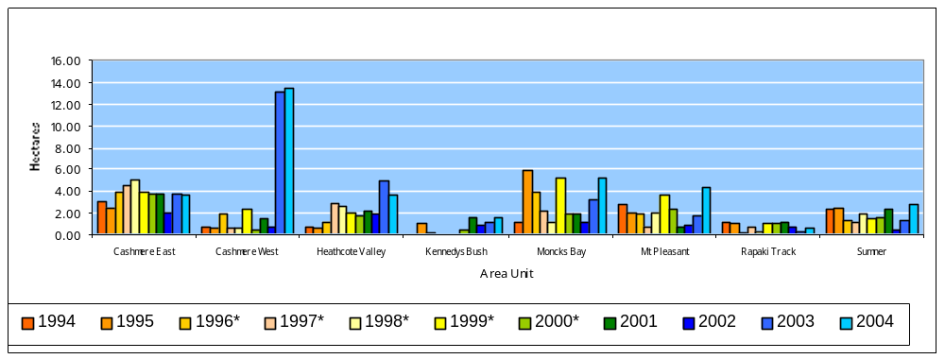
Building consents information provides an indication of the rate, preferred location and nature of residential development in the city. Between July 2001 and June 2004 just under 25,000 building consents were issued for new residential buildings, at an average of around 1900 per year. Of those, 13,810 were for new units and 10,858 were for new dwellings. Since 2001, around 70% of the consents issued for residential development have been for new dwellings, compared with the mid 1990’s peak where unit development dominated residential development.

Building Activity 1992-2004 Take up of Vacant Residential Land 1994-2003
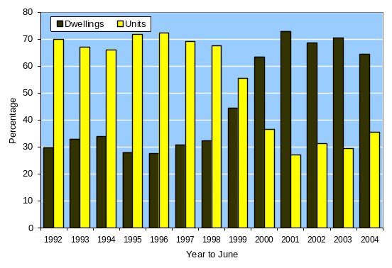
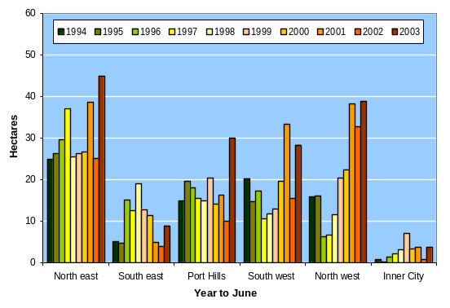

New residential dwellings built between 1991 and 2004 are predominantly located around the northern and southern periphery of the existing urban area of the City. The census areas with the greatest number of consents issued for new residential dwellings since 1991 were Marshland (760), Sawyers Arms (685), Styx (651) and Parklands (620) (all areas associated with new sub divisions.

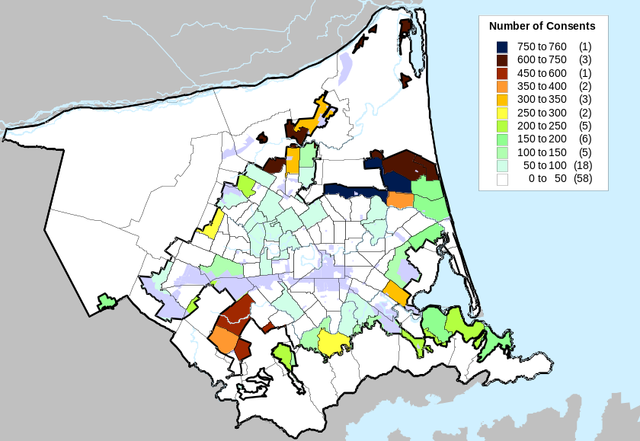

There has been a reasonable number of new dwellings built in existing suburban areas. The majority of new units have been concentrated in residential areas surrounding the central city. The areas with the greatest number of consents for new unite between 1991 and 2004 were Avon Loop (739) and Riccarton ( 613) as well as in the outer areas of Sumner, North Beach, Rawhiti, and Belfast where higher densities are zoned.

Population

Over the past 15 years, Christchurch has experienced steady population growth. At June 2004, Statistics New Zealand estimated the population of Christchurch to be 344,100, up 55,000 or just under 20 per cent from 1991. Statistics New Zealand estimate that Christchurch’s usually resident population will increase to 379,600 by 2026 and continue to increase before a projected gradual decline 2046.

The rate of population growth has also increased. Where population grew by around 3,300 people each year in the decade to 2001, since then the increase has been closer to 5,000 each year and in the year to June 2003, the population of the city increased by close to 7,000 additional people.
Distribution of population in all age groups remained relatively constant in the periods to 1996 and 2001. Children (aged up to 14 years) tend to comprise a higher proportion of the population throughout the whole city, except for the Central City areas. Records show higher populations of children in outer suburbs in the north, east and north-east, and particularly around Halswell in 1996, and in areas of Broomfield, Russley, Jellie Park, Strowan, Holmwood, Styx Mill, Parklands, Aranui and Bromley in 2001.
Young adults tend to comprise a higher proportion of populations in inner suburban and central city area units such as Cathedral Square, Riccarton, Hagley Park and Avon Loop, west along major arterial road corridors and around the university and teachers college.

Distribution of population by age and Area Unit (2001)
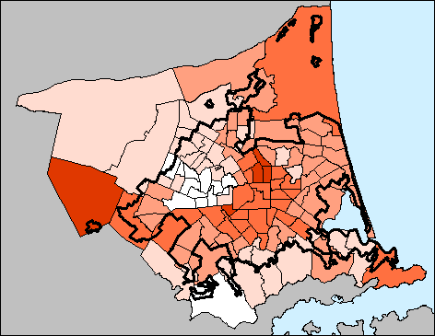
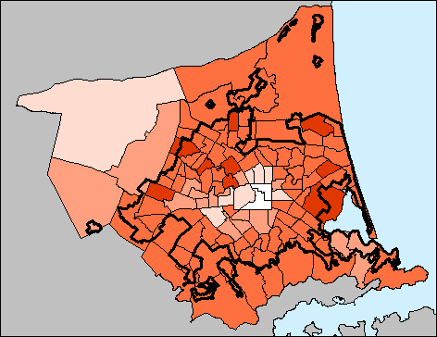
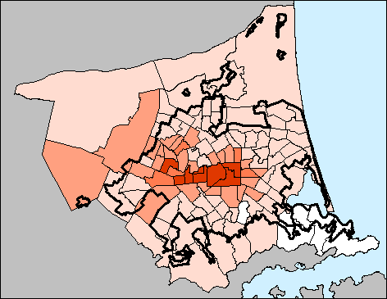
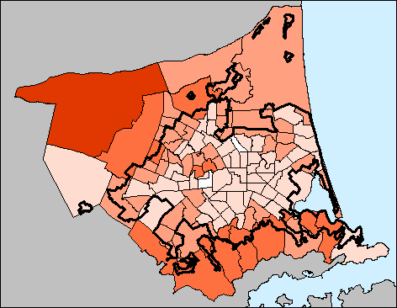
Aged 25 to 44 years
Age 5 to 14 years
Age 15 to 24 years
Aged 45 to 65 years

Residents aged 25 to those around the age of 40 years are generally less concentrated in north-west and hillside area units than in the rest of the City. In contrast, there are generally higher proportions of middle-aged residents in outlying parts of the City, on the hills and in the north-western areas. Elderly residents, over 65 years, are dispersed widely throughout the City, with the highest proportions of elderly in Barrington South, Upper Riccarton and Shirley East.

Where will the city grow?

While the city is predicted to receive overall growth, some areas within the city are predicted to grow at a faster rate than others. The Christchurch City Council is in the process of producing Area Plans which deal directly with some of these areas, and particularly those around the city’s peripheral suburbs. Within new subdivisions, developers are required to make a contribution, either in cash or land equivalent, towards public reserves for open space and recreation.

 | 2001 | 2006 | 2011 | 2021 | total net change
Halswell East | 990 | 2,710 | 3,580 | 6,280 | 5,290
Sawyers Arms | 3,050 | 5,050 | 5,500 | 6,240 | 3,190
Marshland | 5,250 | 6,440 | 6,900 | 9,110 | 3,860
Styx | 3,830 | 5,160 | 5,600 | 7,190 | 3,360
Parklands | 6,150 | 7,150 | 7,490 | 8,320 | 2,170
Avon Loop | 4,730 | 5,130 | 5,330 | 6,070 | 1,340

Towns and centres in the outlying districts are also experiencing growth pressures.

 | 2001 | 2006 | 2011 | 2021 | total net change
Lyttelton | 3,310 | 3,220 | 3,270 | 3,310 | 0
Diamond Harbour | 1,300 | 1,410 | 1,150 | 1,710 | 410
Rangiora North | 4,820 | 5,170 | 5,330 | 5,560 | 740
Rangiora West | 4,010 | 4,350 | 4,440 | 4,500 | 490
Rangiora East | 1,580 | 1,810 | 2,020 | 2,380 | 800
Kaiapoi North | 3,620 | 3,720 | 3,770 | 3,790 | 170
Kaiapoi South | 4,750 | 5,270 | 5,350 | 5,420 | 670
Kaiapoi West | 1,160 | 1,180 | 1,190 | 1,170 | 10
Lincoln | 2,390 | 2,610 | 2,820 | 3,230 | 840
Springston | 3,130 | 3,520 | 4,420 | 6,250 | 3,120
Prebbleton | 1,890 | 2,470 | 2,650 | 2,980 | 1,090
Rolleston | 2,050 | 2,990 | 3,420 | 4,270 | 2,220

